Gift Membership Form
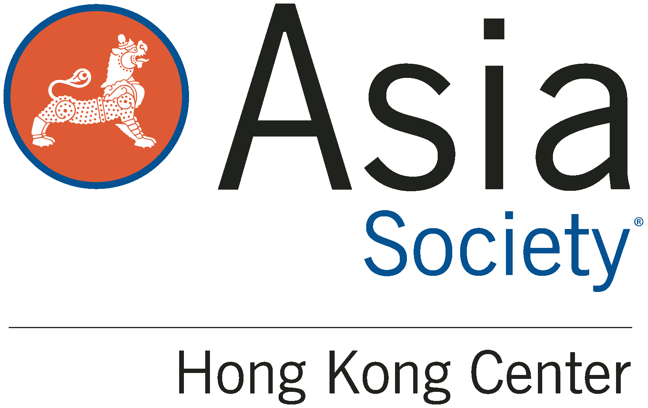
Gift Membership Information
Name of Gift Recipient Mr. Ms. Mrs. Dr.

Recipient E-mail Recipient Mobile
____________________________________________________________________________
Recipient Address
____________________________________________________________________________

Purchaser Name Purchaser E-mail Purchaser Mobile
____________________________________________________________________________
Purchaser Address
____________________________________________________________________________

Mail gift membership E-card to: Send renewal notices to:
- Purchaser
- Recipient
- Purchaser
- Recipient
Membership Categories
- $300 Student (membership for full-time students only)
- $1,600 Individual
- $2,500 Family (up to 3 persons from the same family)
- $25,000 President’s Circle (exclusive benefits for up to 2 persons)

Payment Information
□ Cheque (No.___________)
Please make cheque payable to “Asia Society Hong Kong Center”
□ Credit Card: □ American Express □ MasterCard □ Visa
Cardholder Name: ___________________________ Signature:___________________________

Credit Card Number: _____________________ Expiration Date:__________ CCV: __________
MM/YYYY
Please return this form to:
Development & Membership Department
Asia Society Hong Kong Center, 9 Justice Drive, Admiralty, Hong Kong
membershiphk@asiasociety.org
+852 2524 1099 (Fax)

