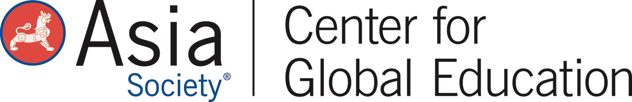

Module 10: International Connections through Social Media
A Future-Ready Workforce: Preparing Community College Students for a Global Economy

Faculty Module 10:
International Connections through Social Media

Faculty Guide

Funded through the generous support of 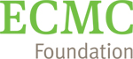

Technology and social media influence every aspect of our lives from personal use to business, education, and training environments. This module will provide postsecondary educators with insight into how business leaders utilize social media for growth in a global society, explore social media business strategies, as well as tools to lead discussions with students on responsible global digital citizenship.
Module Objectives:
- Analyze social media use for business.
- Evaluate an inquiry-based model for engaging students in social media discussions.
- Investigate how to teach students to become global digital citizens through social media.

Audience:
This module is geared towards community college or program administrators, staff, or faculty to gain a greater understanding of how to support global competence integration efforts.

Module Outline:
- Overview of International Connections of Social Media (included in this packet for note taking)
- Rephrasing Open- and Close-Ended Questions (included in this packet for notetaking)
- Questions to Guide Student Discussion (included in this packet for notetaking)
- Overview of Question Formulation Technique: A tool for inquiry based learning
- Social Media Influences in Your Industry
- Driving Questions for using social media (included in this packet for notetaking)
- Overview of Global Digital Citizenship

International Connections of Social Media

Questions

Rephrasing Open- and Close-Ended Questions

Questions to Guide Student Discussion – Top Three Questions

Driving Questions

How can you utilize your driving questions to encourage inquiry and engagement among your students?

Your next steps are:

- After reviewing the specific ways social media influences your career field, brainstorm examples that you have seen or experienced. How can you use these examples in conjunction with the questions you created related to the use of social media and international connections in your industry, to help your students develop their global competence?

- Consider creating a lesson similar to Robin’s tilapia story featured at the beginning of the module. What products or services in your field have international pathways or supply chains that your students can trace from raw material to finished product or service? How does (or could) social media facilitate the process? How can social media facilitate transparency in the process for consumers?

- Try using the Question Formulation Technique during a student discussion to help students think critically about their use of social media and how that usage might impact their work within the industry.

- Revisit the Postsecondary Global Leadership Performance Outcomes. Where is global digital citizenship and responsible social media usage reflected in the outcomes?

- Identify places within your curriculum to incorporate the concept of responsible social media use as a critical component of global digital citizenship and as an essential skill for employability.

- Be sure to check Asia Society’s Global CTE Toolkit for free tools and resources.

When you have completed these activities and all ten modules, you will have completed the faculty development program A Future-Ready Workforce: Preparing Community College Students for a Global Economy. Congratulations!

